Ideation Phase
Define the Problem Statements

Date | 28 June 2025
Team ID | NM2025TMID00021
Project Name | Streamlining Ticket Assignment for Efficient Support Operations
Maximum Marks | 2 Marks

Customer Problem Statement Template:
In current support operations, the process of ticket assignment remains largely manual and time-consuming, leading to inefficiencies and operational delays. Support agents face challenges in accurately and promptly assigning tickets to the appropriate departments, which results in backlogs, increased response times, and decreased productivity. Similarly, support managers encounter difficulties in monitoring ticket flow and managing staff workloads effectively due to the lack of real-time analytics and process visibility. These inefficiencies not only reduce overall productivity but also negatively impact employee morale and customer satisfaction levels. Therefore, there is an essential need to implement a streamlined and automated ticket assignment system that enhances operational efficiency, optimizes resource allocation, and ensures timely resolution of customer issues.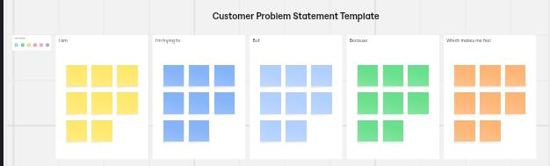
Reference : https://miro.com/templates/customer-problem-statement/
Example:
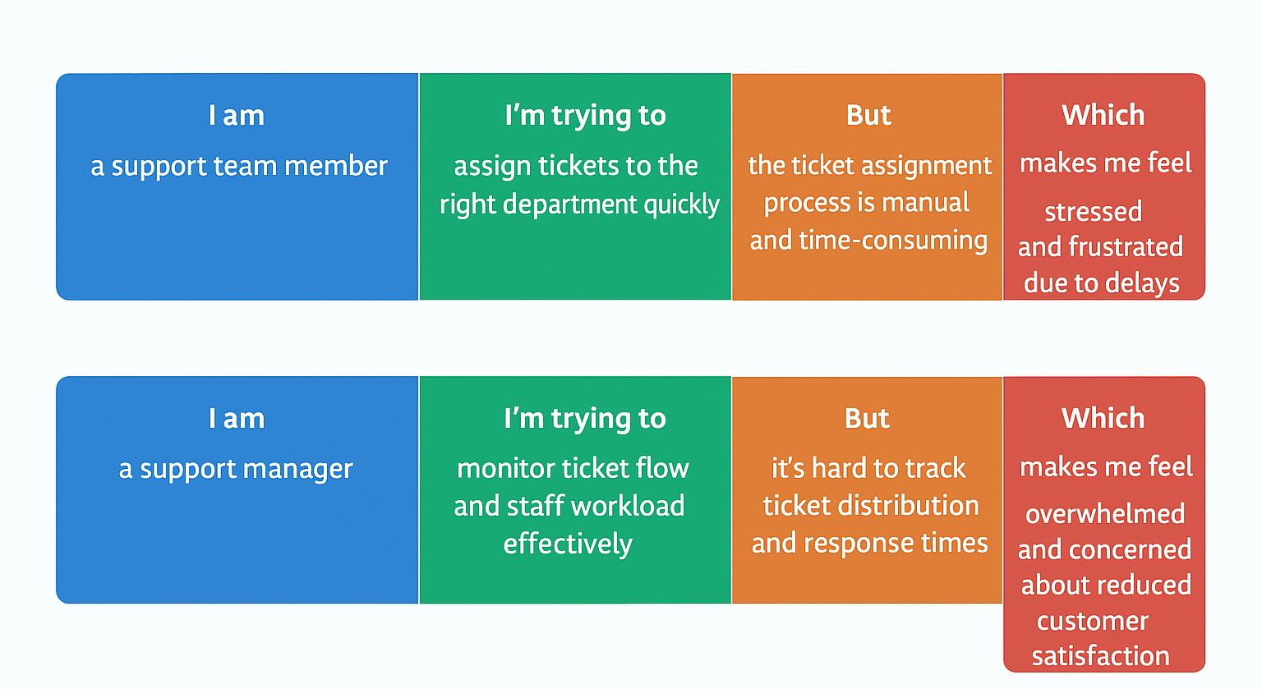
Problem Statement (PS) | I am (Customer) | I’m trying to | But | Because | Which makes me feel
PS-1 | A Support team member | Assign tickets to the right department quickly | The ticket assignment process is manual and time consuming | There’s no automated system to categorize and route tickets efficiently | Stressed and frustrated due to delays
PS-2 | A support manager | Monitor ticket flow and staff workload effectively | It’s hard to track ticket distribution and response times | The lack of real-time analytics and visibility makes it difficult to balance workloads | Overwhelmed and concerned about reduced customer satisfaction

Problem Statement 1 (PS-1):
I am a support team member,
I’m trying to assign tickets to the right department quickly,
but the ticket assignment process is manual and time-consuming,
because there’s no automated system to categorize and route tickets efficiently,
which makes me feel stressed and frustrated due to delays.

Problem Statement 2 (PS-2):
I am a support manager,
I’m trying to monitor ticket flow and staff workload effectively,
but it’s hard to track ticket distribution and response times,
because the lack of real-time analytics and visibility makes it difficult to balance workloads,
which makes me feel overwhelmed and concerned about reduced customer satisfaction.

